# QRS complex

The **QRS complex** is a name for the combination of three of the graphical deflections seen on a typical electrocardiogram (EKG or ECG). It is usually the central and most visually obvious part of the tracing; in other words, it's the main spike seen on an ECG line. It corresponds to the depolarization of the right and left ventricles of the human heart and contraction of the large ventricular muscles.

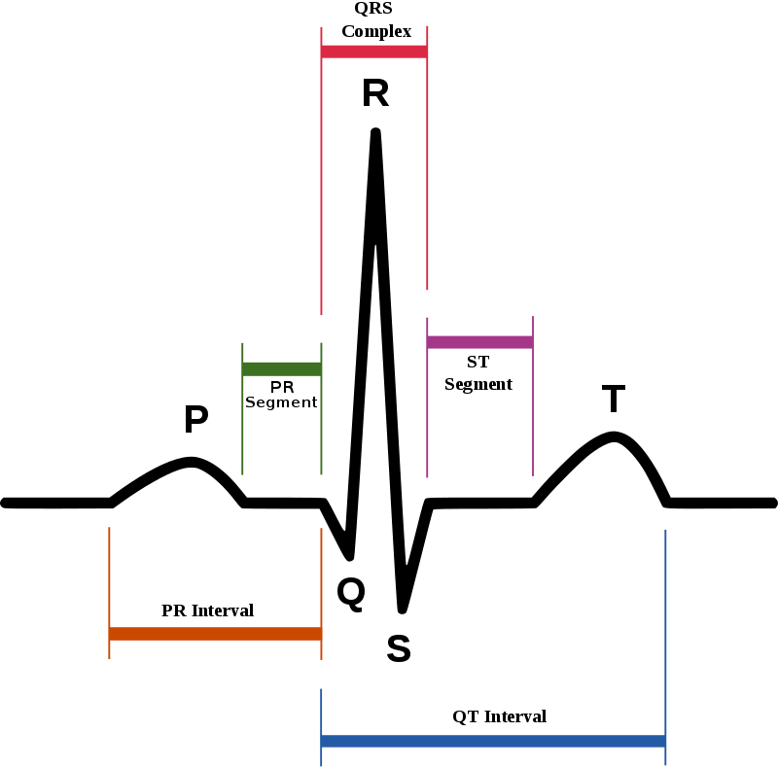

QRS duration:

1. In adults, the QRS complex normally lasts 0.06–0.10 s;
2. RR interval: 0.6-1.2 seconds:.Sometimes sinus arrhythmia can have a more or less cyclic pattern, starting with a long RR interval, followed by a number of shortening RR intervals, until a long RR appears
3. P wave: 80 milliseconds.A P wave with increased amplitude can indicate hypokalemia. It can also indicate right atrial enlargement. A P wave with decreased amplitude can indicate hyperkalemia. Bifid P waves (known as P mitrale) indicate left-atrial abnormality - e.g. dilatation or hypertrophy.
4. PR interval: 120-200 milliseconds.

**PR Interval > 0.2 s (see Heart Block)**

**PR Interval < 0.12 s (see Wolff Parkinson White Syndrome (WPW)**

1. PR segment: 50-120 milliseconds.
2. QRS complex: 80-100 milliseconds

– Ventricular ectopic or escape pacemaker

– Ventricular pacing by cardiac pacemaker

1. J-point: N/A.
2. ST segment: 80-120 milliseconds.

Atrial repolarization (e.g., at fast heart rates the atrial T wave may pull down the beginning of the ST segment)

Ventricular conduction abnormalities and rhythms originating in the ventricles

1. T wave: 160 milliseconds

amplitude ≥ 5 mm in I, II V2–V6 when R amplitude ≥ 5 mm in aVL when QRS mainly upright in aVF.

T amplitude = -1 to -5 in I, II, V2–V6 when R amplitude ≥ 5 mm in aVL when QRS mainly upright in aVF.

T wave flat or small diphasic in I, II, V2–V6 when R amplitude ≥ in aVL when QRS mainly upright in aVF.

T amplitude positive and T/R amplitude radio <1/20 in any of leads I, aVL, V6: R wave amplitude must be ≥ 10.0 mm.

In children and during physical activity, it may be shorter. The Q, R, and S waves occur in rapid succession, do not all appear in all leads, and reflect a single event and thus are usually considered together. A Q wave is any downward deflection immediately following the P wave. An R wave follows as an upward deflection, and the S wave is any downward deflection after the R wave. The T wave follows the S wave, and in some cases, an additional U wave follows the T wave.

The point where the QRS complex meets the ST segment is the J-point. The J-point is easy to identify when the ST segment is horizontal and forms a sharp angle with the last part of the QRS complex.

**D1, D2, D3 are bipolar leads that translate**

**the potential difference between two members:**

**D1: between right arm (pole -) and left arm (pole +)**

**D2: between right arm (pole -) and left leg (pole +)**

**D3: between left arm (pole -) and left leg (pole +)**

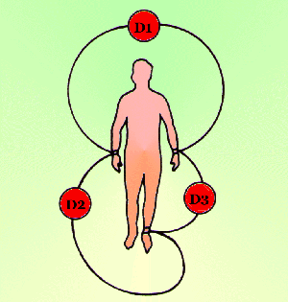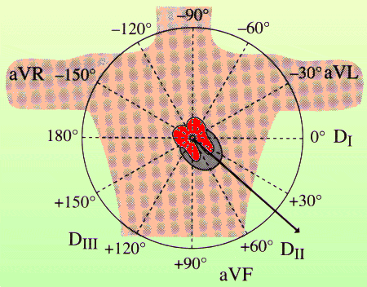

**For a routine analysis of the heart’s electrical activity an ECG recorded from 12 separate leads is used. A 12-lead ECG consists of three bipolar limb leads (I, II, and III), the unipolar limb leads (AVR, AVL, and AVF), and six unipolar chest leads, also called precordial or V leads, (, , , , , and ).**

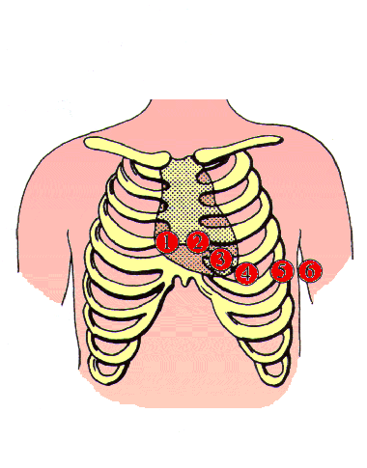

**Lead I: Right arm-negative, Left arm-positive**

**Records electrical differences between the left and right arm electrodes.**

**Lead II: Right arm-negative, Left leg-positive**

**Records electrical difference between the left leg and right arm electrodes.**

**Lead III: Left arm-negative, Left leg-positive**

**Records electrical differences between the left leg and left arm electrodes.**

**Lead IV also called AVR,Lead aVR Augmented Vector Right, positive electrode right shoulder**

**Lead V also called AVL,Lead aVL Augmented Vector Left, positive electrode left shoulder**

**Lead VI also called AV,Lead aVF Augmented Vector Foot, positive electrode on Foot.**

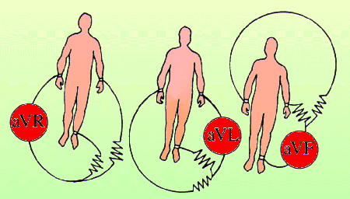

**aVR means augmented Vector Right; the positive electrode is on the right shoulder.**

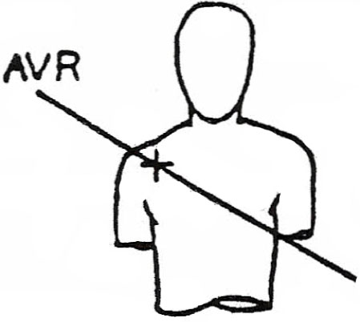

**aVL means augmented Vector Left; the positive electrode is on the left shoulder.**

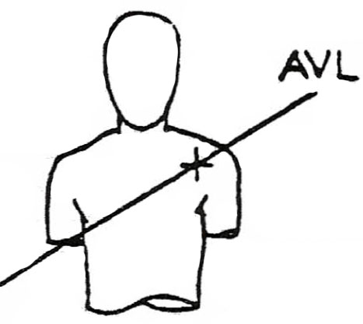

**aVF means augmented Vector Foot; the positive electrode is on the foot.**

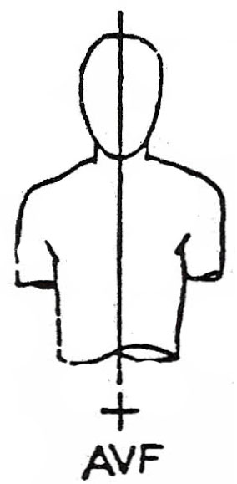

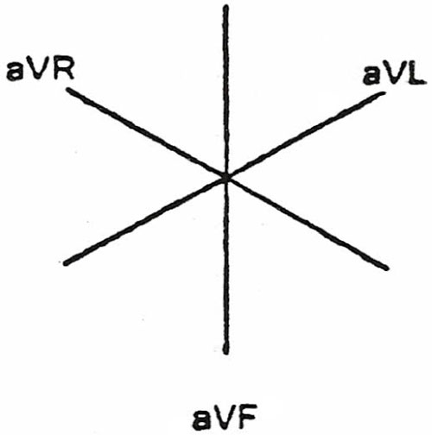

Remaining All components

[**https://www.nurseslearning.com/courses/nrp/nrp1619/section%205/index.html**](https://www.nurseslearning.com/courses/nrp/nrp1619/section%205/index.html)

**D1,D2,D3**

[**https://translate.google.com/translate?hl=en&sl=fr&u=http://foulon.chez-alice.fr/Alie%25202.000/DATAS/MODULE1/derivECG.htm&prev=search**](https://translate.google.com/translate?hl=en&sl=fr&u=http://foulon.chez-alice.fr/Alie%25202.000/DATAS/MODULE1/derivECG.htm&prev=search)